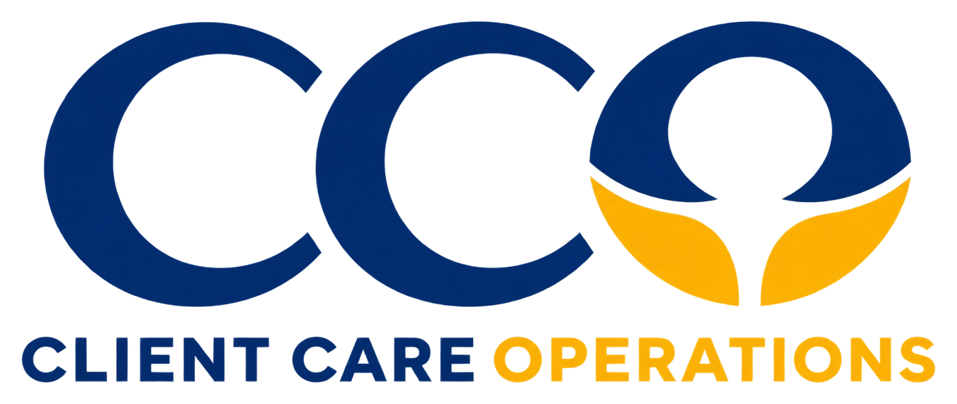 | Practical Tools & Checklists  Planning 03  Version 2.1 · October 2026

Planning 03 · Client Care Operations

Software Requirements Discovery Checklist
A structured starting point for commissioning custom software, SaaS products, or systems integration.
━━━
Prepared as an educational planning tool. It is not a certification, a legal opinion, or an assessment of a particular organization.
6  Discovery domains | 24  Checklist items | 1  Executive summary

How to use this checklist
1 Complete the project overview with the project sponsor and operating owner (Section 01). | 2 Work through the six discovery domains. Tick an item only when it is documented, and note any gap and its owner (Section 02).
3 Capture key requirements, each with a priority and an acceptance check (Section 03). | 4 Summarize the position for decision-makers and agree the next step (Sections 04–05).
Discovery record
Organization / team | Completed by | Date

SECTION 01 ———

Project overview
— Proposed project / sponsor
— Current process and principal frustration
— Business objective and how success will be measured
— Initial users, locations and planned scale

SECTION 02 ———

Discovery checklist
Tick an item only when it is documented. Use the notes column to record the gap, the owner, or where the evidence is held.
DOMAIN 1 Business case and scope |  | NOTES / GAP / OWNER
☐ | The business problem is stated without prescribing a technology.
☐ | Essential versus optional requirements have been distinguished.
☐ | A project sponsor and operating owner are identified.
☐ | The first usable release and excluded scope are documented.

DOMAIN 2 People, roles and journeys |  | NOTES / GAP / OWNER
☐ | User groups and responsibilities are listed.
☐ | At least three real end-to-end workflows are mapped.
☐ | Permissions for viewing, editing, approving and exporting are defined.
☐ | Training, accessibility and language needs are considered.

DOMAIN 3 Data and integrations |  | NOTES / GAP / OWNER
☐ | Records, required fields and authoritative data sources are listed.
☐ | Necessary integrations and supported APIs are identified.
☐ | Migration and data-quality responsibilities are assigned.
☐ | Failures, duplicates and synchronization conflicts are considered.

DOMAIN 4 Privacy, security and governance |  | NOTES / GAP / OWNER
☐ | Sensitivity and lawful use of personal information are reviewed.
☐ | Authentication, authorization and tenant isolation are considered where relevant.
☐ | Audit trail, retention, deletion and data export needs are documented.
☐ | Security testing and incident escalation are planned.

DOMAIN 5 Experience and reliability |  | NOTES / GAP / OWNER
☐ | Mobile and desktop contexts are identified.
☐ | Availability, performance and recovery expectations are agreed.
☐ | Error and empty states are included in design acceptance criteria.
☐ | Monitoring, backup and disaster recovery owners are assigned.

DOMAIN 6 Commercial ownership and delivery |  | NOTES / GAP / OWNER
☐ | Delivery milestones and sign-off criteria are documented.
☐ | Development, hosting, maintenance and support costs are considered.
☐ | Source-code, licensing, vendor and data ownership terms are reviewed.
☐ | Post-launch support, change requests and handover are included.
SECTION 03 ———

Requirements table
Record each essential requirement or scenario with its priority and the check that will confirm it has been met.
ID | Requirement / scenario | Priority | Acceptance check
R01
R02
R03
R04
R05
R06
R07
R08
R09
R10
R11
R12
SECTION 04 ———

Executive requirements summary
A one-page view of discovery status for sponsors and decision-makers. Complete it after the checklist and requirements table.
Discovery domain | Items documented | Principal gap or open decision | Owner
1. Business case and scope | / 4
2. People, roles and journeys | / 4
3. Data and integrations | / 4
4. Privacy, security and governance | / 4
5. Experience and reliability | / 4
6. Commercial ownership and delivery | / 4

— First usable release and excluded scope
— Principal risks, dependencies and decisions required

SECTION 05 ———

Project readiness and next step
☐ Ready for discovery workshop |  | ☐ Needs process mapping
☐ Requires privacy/security review |  | ☐ Reconsider buy vs. build

OWNER |  | NEXT REVIEW

Reference guidance
— AWS SaaS Lens — general design principles
https://docs.aws.amazon.com/wellarchitected/latest/saas-lens/general-design-principles.html
— AWS SaaS Lens — infrastructure protection
https://docs.aws.amazon.com/wellarchitected/latest/saas-lens/infrastructure-protection.html
This educational checklist does not replace architecture review, professional legal advice, or requirements sign-off. No third-party endorsement is implied.

